AIML Development Environment Setup
Things to install
- Anaconda Distribution
- VS Code with Python extensions

Installing Anaconda Distribution
- Download Anaconda Distribution from
https://www.anaconda.com/download/success?reg=skipped
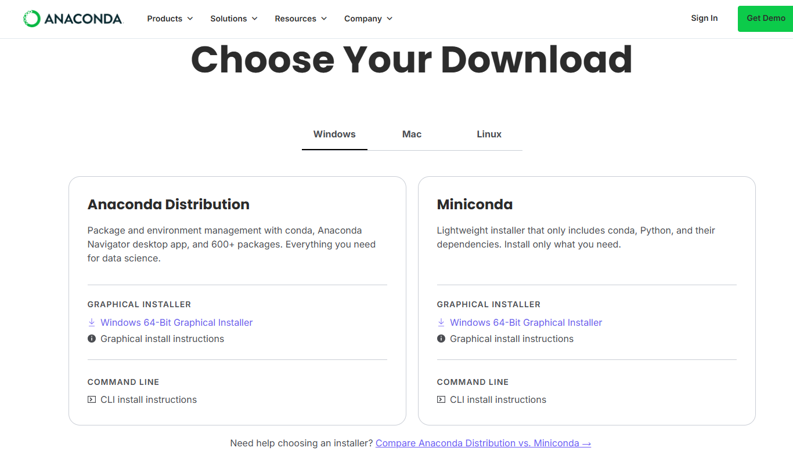
- Go to downloads folder and run installer

Create Anaconda environment for AIML
- Run Anaconda prompt
- Run “conda create -n aimlenv numpy pandas matplotlib scikit-learn seaborn jupyter notebook”
- Run “conda activate aimlenv” to activate new environment

Installing VS (Visual Studio) Code
- Go to https://code.visualstudio.com/download, download VS Code installer according to the OS of your computer
- Run the installer to install (find it in downloads folder)
- Open VS Code
- Go to Extensions and install the following highlighted extensions (it will automatically install other packaged extensions)
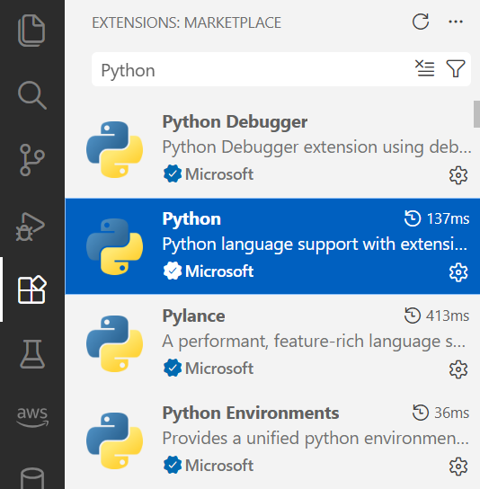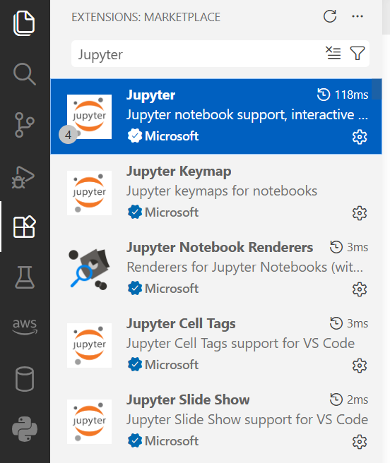
- Open your AIML Practical Labsheets folder (e.g. “Chp 1 M16 - Data Import and Processing”) to start working on the labs.
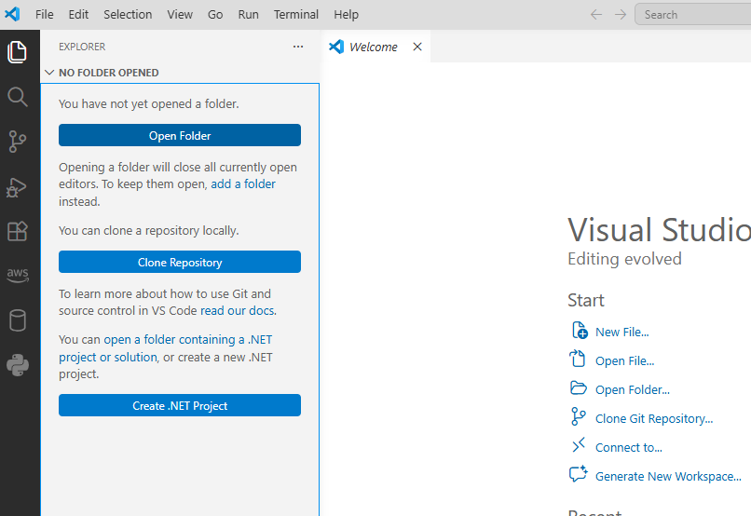
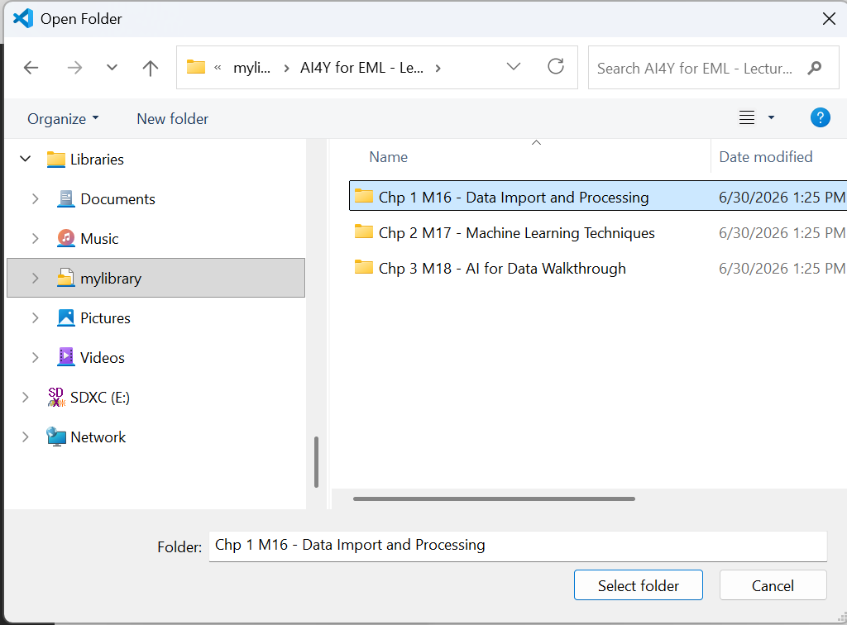
- To run the first lab, click on “(1) [Youth] M16 - Obtaining_data.ipynb” and select the correct Kernel (aimlenv Anaconda Environment).
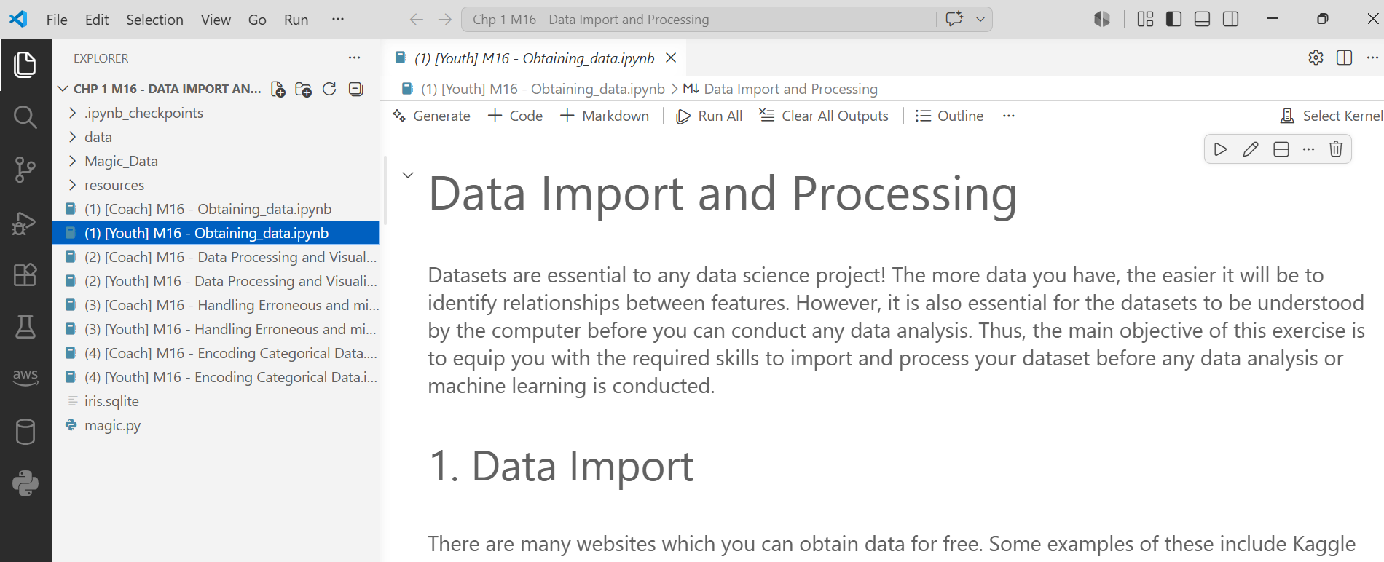 
- 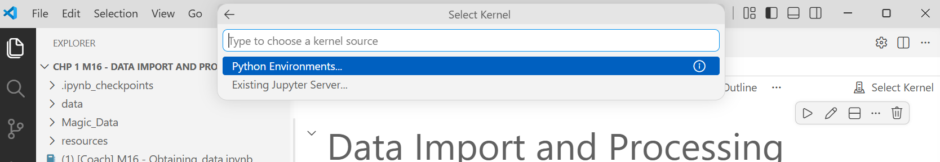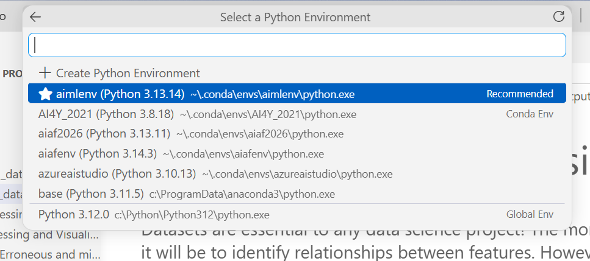
- Check that the correct Kernel (aimlenv) is selected now.
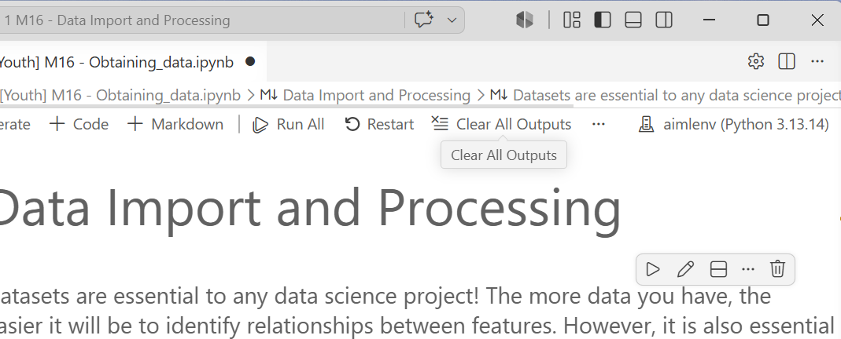
- Click on the play button beside the first code cell to run the code.
